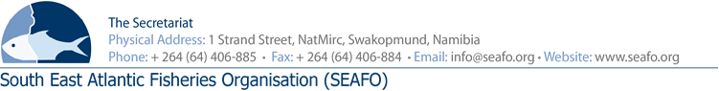

LIST OF DOCUMENTS FOR 11th MEETING OF THE STANDING COMMITTEE on ADMINISTRATION & FINANCE (SCAF) - 2019

CHAIRPERSON: Mr. Hideki Moronuki (Japan 2018-2019) VENUE: Strand Hotel, Swakopmund
VICE-CHAIR: To be confirmed (Korea 2018-2019) DATE: 27 November 2019

Document Ref.  Number | Agenda  Item | Document Title | Provider | Availability of  Document
DOC/SCAF/00/2019 | All | List of Documents | Secretariat | Available before meeting
DOC/SCAF/01/2019 | All | Provisional Agenda of the 11th Meeting of SCAF | Secretariat | Available before meeting
DOC/SCAF/02/2019 | All | Provisional Annotated Agenda of the 11th Meeting of SCAF | Secretariat | Available before meeting
DOC/SCAF/03/2019 | 5 | Annual Financial Statements 2018 | Auditors/Secretariat | Available before meeting
DOC/SCAF/04/2019 | 5 | Auditors’ Management Letter 2018 | Auditors/Secretariat | Available before meeting
DOC/SCAF/05/2019 | 6 | Executive Secretary’s Report on Administration & Finance | Secretariat | Available before meeting
DOC/SCAF/06/2019 | 6 | Staff Regulations to comply with Namibian Labour Law | Secretariat | Available before meeting
DOC/SCAF/07/2019 | 7 | Provisional 2020 & 2021 forecast budget | Secretariat | Available before meeting
DOC/SCAF/08/2019 | 7 | Provisional 2020 & 2021 forecast budget explanatory notes | Secretariat | Available before meeting
DOC/SCAF/09/2019 | 8 | Contribution of Contacting Parties | Secretariat | Available before meeting

Circulation Date: 27 October 2019

